31/08/2016

|  |
| --- |
| Documentation | Arnaud Tschupp |

|  |  |
| --- | --- |
| DCU | Learning Analytic Tool |

Contents

Introduction 1

Structure of the tool 2

Data Object 2

Sample object 2

Learning Analytic 3

The Tool 3

Manipulation 4

Separated Functions 4

Sample Object 4

Read and write Files 6

Read 6

Write 6

Populate 7

First step 7

Second step 7

Third step 7

Conclusion 7

# Introduction

The learning analytic tool has been made to see in an easy way all the results off the students. In this document we’ll see the structure of the tool and what it can do actually. This tool is not really a tool but you must see it more as a library.

# Structure of the tool

The tool has been coded in python for the easy way to use. The tool has been made in three parts in the aim of an easy read of the code, an easy use and fewer bugs.

## Data Object

I choose to create a data object because I needed to define what a data is. You can see three different data.

The first one is the data in a text file. There is an IP of the computer, Name of the Student, Type and Topic of the exercise, Score of the Student, Timestamp at the start of the exercise and Timestamp at the end of the exercise. So a text Data looks like this:



The second one is in the data base. There is the Id of the data, Id of the student, Type and Topic of the exercise, Score of the student, Datetime at the start of the exercise and Datetime at the end of the exercise. So a database Data looks like this:



The third one is a data in a csv file. There is Id of the data (generally NULL), Id of the student, Type and Topic of the exercise, Score of the student Datetime at the start of the exercise and Datetime at the end of the exercise. So a database Data looks like this:



The data object has some function to read and write a data in each case. You can read the commentaries in the code for further explanations.

## Sample object

A sample object is just a list of data object. This object was essential because I needed to treat more than only one data.

This object regroups many methods to work with data and to make figures and files with them. Thanks to that object you can make figures, files or populate a database with data objects. But we’ll see later how that’s really works.

## Learning Analytic

This part is a kind of main for the tool, here you can do whatever you want with sample objects. This is what you’ll execute to make the program run.

There are some examples of what you can do with the tool but you can change as you want everything.

# The Tool

At the first sight this tool looks basic, because it is, but you can do many things with it. You can do manipulations on the data, work on files and populate databases.

## Manipulation

Most of the methods to work on data manipulation are in the Sample object. There are just two functions that are separated.

### Separated Functions

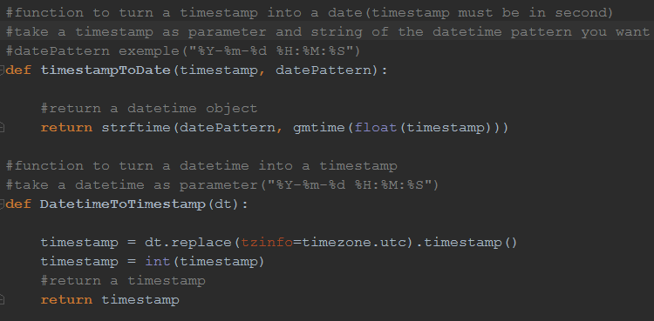

These are two functions to change a date in timestamp or a timestamp into a date. There are important because a timestamp is easier to use in the code but a date is easier to read for a human. That’s why you’ll see many uses of them in the code.

### Sample Object

You can make three kind of figures with the sample object’s methods. You can make a pie of the average score of the sample: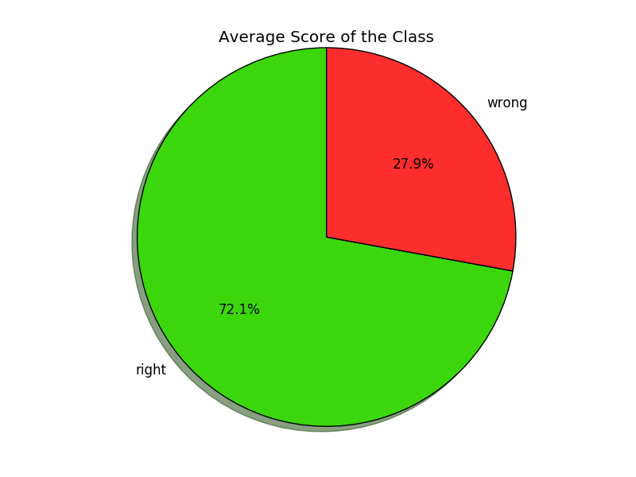You can make a plot of the time spend on each exercise: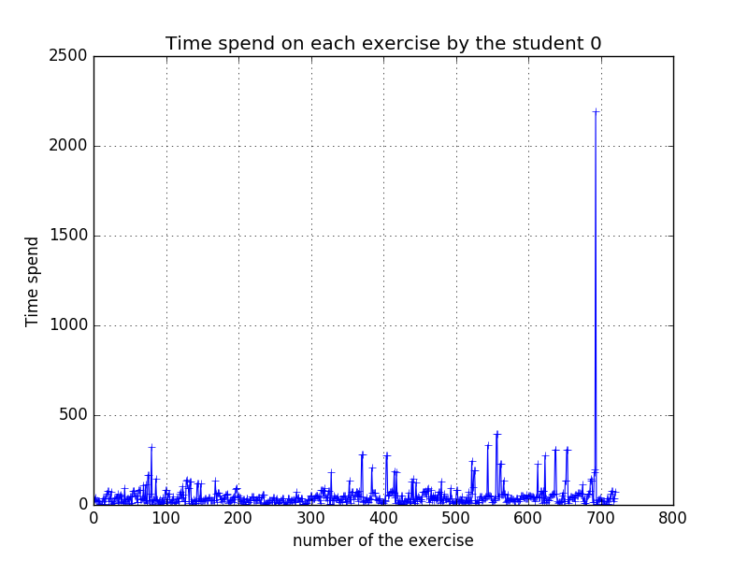

And you can make the plot of the score’s evolution by week :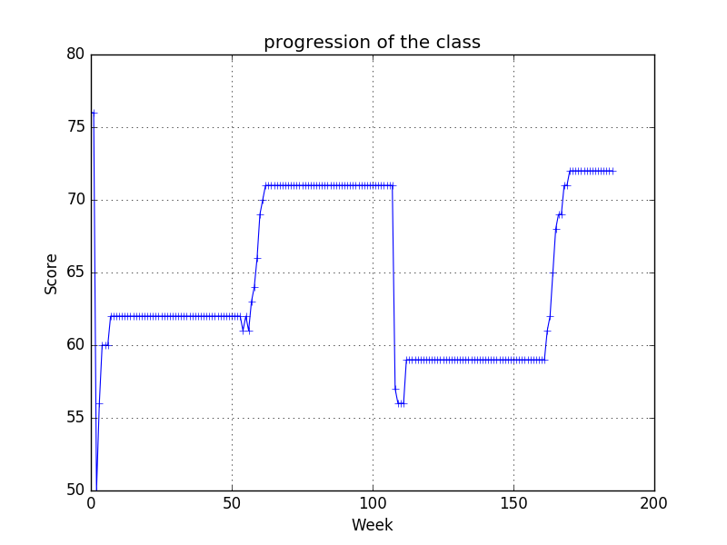

## Read and write Files

### Read

There are two different way to read data in the tool. There is the text way and the database way.

If you want to read a text file you just have to create a sample object and then use sampleReadTxtSample method to read the text file.

If you want to read data from the database you have to create a sample object and then use sampleReadDBSample method to read data in the database.

### Write

There are two different way to write a sample of data. You can write it in a text file or in a csv file.

If you want to write a csv file you can use sampleCsvWrite or sampleCsvAddWrite with the name of the file. The difference between the two is that the first one rewrite on the file if exist and the other just add content in the file if exist.

If you want to write a txt file you can use sampleWrite or sampleAddWrite with the name of the file. The difference between the two is that the first one rewrite on the file if exist and the other just add content in the file if exist.

## Populate

If you want to populate data in the database you can use the tool to help you.

### First step

You have to read data you want to populate using one of the two functions presented above

### Second step

You have to write the sample you’ve read in a csv file using one of the two functions presented above. I recommend using sampleCsvWrite to rewrite on the file otherwise it can make some bugs.

### Third step

Go on phpmyadmin and populate the data by importing the csv file.

# Conclusion

The tool is on start and is not perfect, you can change what you want, add things, etc. Nevertheless you can already do many things with it. I let many examples of what I’ve done to help.